# Assignment 1

# Traffic management system

ER Logical Model

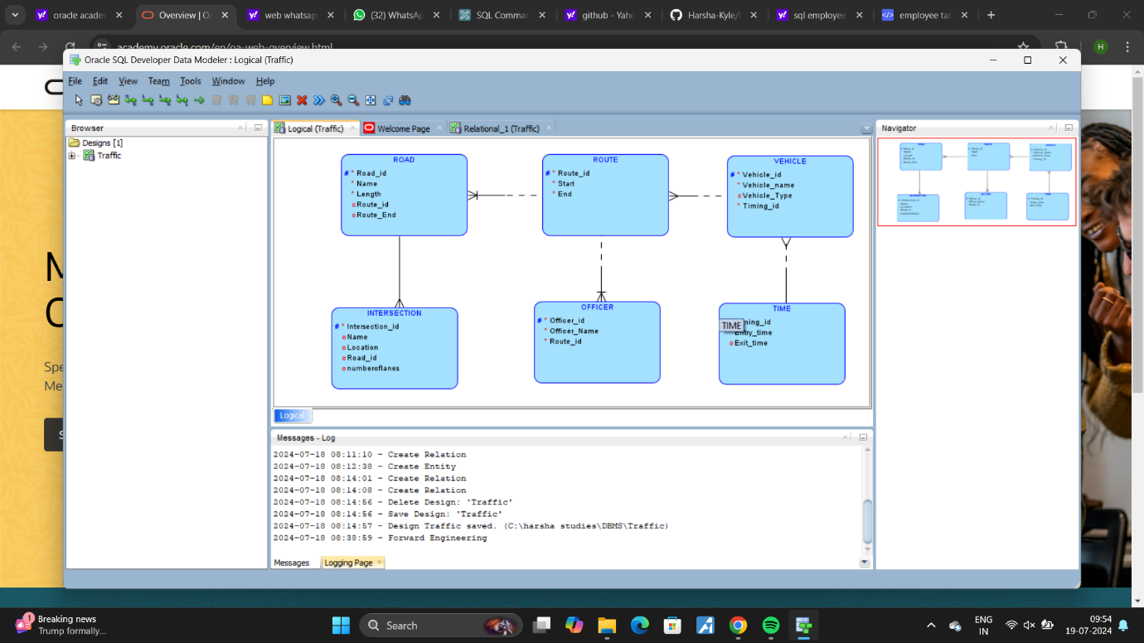

ER Relational model

